Complete with AM, IS, HAVE GOT, or HAS GOT – Doplň AM, IS, HAVE GOT nebo HAS GOT
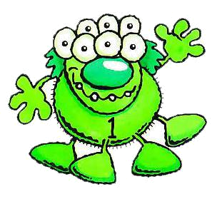
Hi, My name _____ Martin.
I ________ a monster.
I ___________ 144 years old.
I ________ green. I______ short and fat.
I ____________ four legs and two hands.
I ___________________ seven eyes.
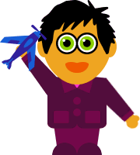
He ________ John.
He ___________ a boy.
He ___________ 10 years old.
He ___________ short black hair.
He ________ two legs and two hands.
He _______________ two green eyes.
He _____________ a blue plane.

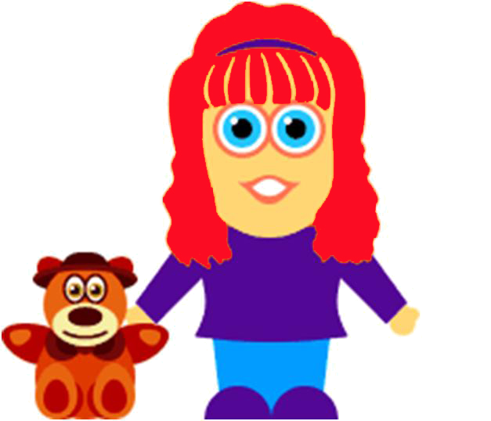
She ________ Sue.
She__________ a girl.
She___________ 12 years old.
She_____________ funny☺
She ___________ red hair.
She __________ two legs and two hands.
She_________ a brown teddy bear.

Who is it? Kdo je to?

Read the description and find who it is.Přečti si popis a najdi kdo to je.
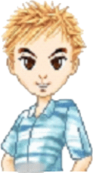
Suzy Bill Becky Kelly Tom Pam

- She has brown hair and blue eyes. It's Kelly .
- He has blond hair and blue eyes. It's _______
- She has black hair and blue eyes. It's _______
- He has blond hair and brown eyes. It's _______
- She has blond hair and brown eyes. It's _______
- She has brown hair and green eyes. It's _______
AND YOU? Complete the sentences: A TY? Doplň věty:
Poslední dva řádky můžeš napsat o sobě co chceš☺
My name is…………………………………………….
I am………………………………years old.
I have got……………………………………………………hair.
I have got…………………………………………………….eyes.
I have got……………………………………………………
…………………………………………………………………………..
…………………………………………………………………………..

