COMPLETE THE WORDS AND FIND THEM IN THE WORDSEARCH

D_ _ _ _ J_ _ _ _ S_ _ _ _ S_ _ _ _

C_ _ _ S_ _ _ _ S_ _ _ _ S_ _ _ _ _ _

H_ _ S_ _ _ _ _ B_ _ _ _ J_ _ _ _ _

S_ _ _ _ T-_ _ _ _ _ G_ _ _ _ _ B_ _ _ _
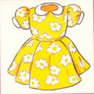
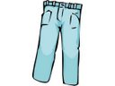
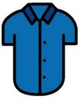
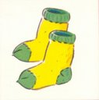
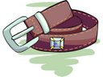
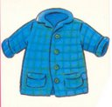
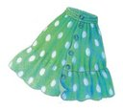
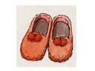
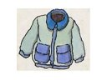

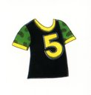
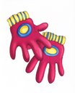
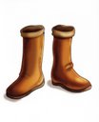
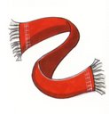
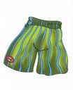
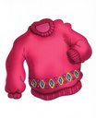
S | S | E | R | D | H | A | T | B
R | H | S | O | C | K | S | A | E
E | O | B | O | O | T | S | S | L
T | R | I | H | S | - | T | O | T
A | T | R | S | N | A | E | J | R
E | S | C | A | R | F | K | T | I
W | S | K | I | R | T | C | A | H
S | E | V | O | L | G | A | O | S
S | H | O | E | S | O | J | C | S

READ AND COLOUR

SARA IS WEARING A PURPLE DRESS
A PINK T-SHIRT AND WHITE SHOES

BETTY IS WEARING A RED SWEATER,
BLUE JEANS AND BROWN SHOES.HER
BAG IS BROWN TOO.

KAREN IS WEARING A LIGHT BLUE
DRESS AND BLUE SHOES

SAM IS WEARING AN ORANGE AND
YELLOW T-SHIRT, BLUE SHORTS
AND GREY TRAINERS

PETER IS WEARING A RED AND GREEN
CAP, A WHITE AND BLUE T-SHIRT,
GREEN SHORTS, WHITE SOCKS AND
BLUE TRAINERS

BETTY
KAREN
SAM
PETER
SARAH

