Name ____________________________________ Date_____________

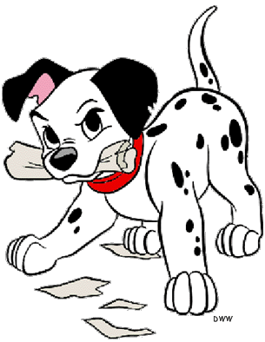




Complete the sentences with have got or has got.
Doplň do vět have got nebo has got.

My brother __________ a motorbike.
Charles and Kim (they) __________ 4 children.
We __________ two cats and a dog.
Alan __________ two snakes.
She __________ a new dress.
I __________ a new skateboard.
My house __________ a big garden.
We __________ orange hair and green eyes.
Maria __________ a new videogame.
Complete the sentences with haven’t got or hasn’t got.
Doplň do vět zápor haven’t got nebo hasn’t got

I _______________ a dog.
Charlie ____________ a TV in his room.
You ____________ long hair.
The Simpsons ____________ a car.
Your cat ____________ blue eyes.
Paul and Sara ____________ a cat.
My brother __________ a bike.
We ____________ a big house.
Samantha __________ brothers or sisters.

