
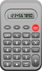

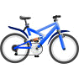
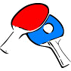

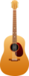

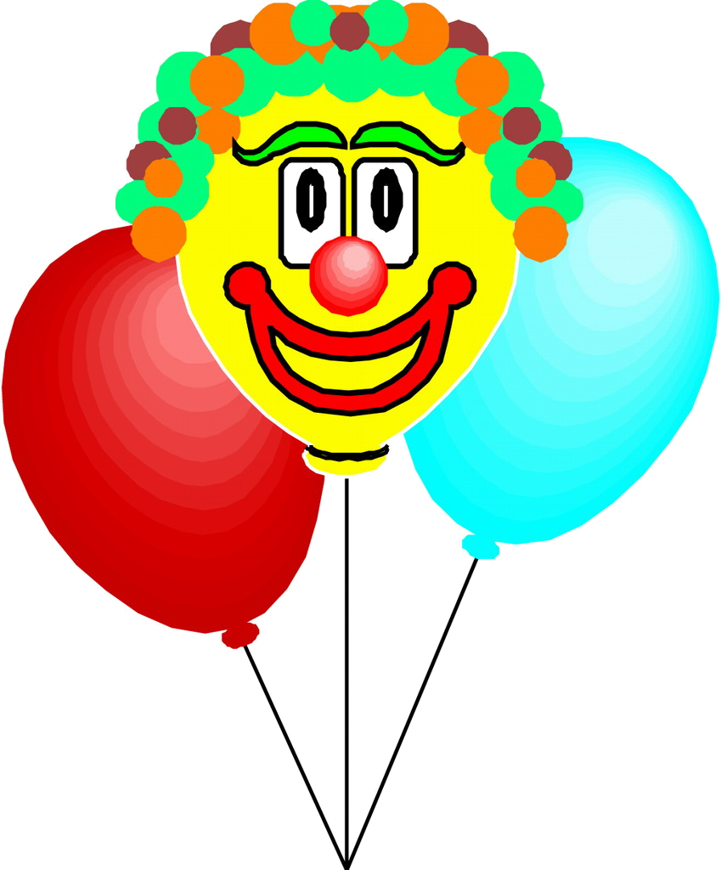
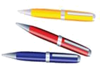

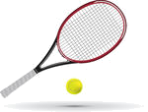
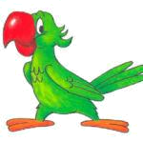
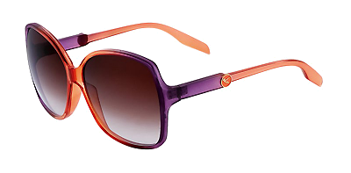
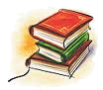
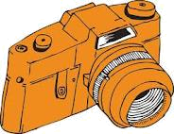
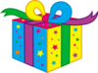
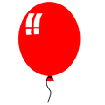

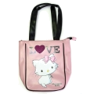


Have Got-Has Got
1. Fill in have got, has got:
1. Sandra ______ a new umbrella.
2. Andrew ______ a calculator.
3. They ______ bikes.
4. Sandra ______ a parrot.
5. Andrew ______ a dog.
6. They _______ books.
7. Sandra ______ a present.
8. Andrew ______ 3 balloons.
9. Sandra ______ a bag.
10. Andrew ______ a guitar.
11. Sandra ______ sunglasses.
12. Andrew ______ a clock.
Na tomto pracovním listě doplníš 3 cvičení:
Doplň do vět have got nebo has got – použij tabulku
Doplň do vět haven´t got nebo hasn´t got – použij tabulku
Odpověz na otázky podle obrázků:
+ Yes, I have.
No, I haven´t.
2. Fill in hasn’t got, haven’t got:
1. Sandra _______ a laptop.
2. They ________ flowers.
3. Sandra _______ table tennis rackets.
4. Andrew _______ a tennis rackets.
5. Sandra _______ a calculator.
6. Andrew ________ a camera.
7. They _______ mobiles.
8. Sandra _______ three pens.
9. They _______ cats.
10. Andrew _______ a parrot.
11. Sandra _______ a clock.
Andrew
Sandra
+
+
+
+
+
-
-
-
-

3. Look at the pictures and answer:
1. Have you got a present? __________
2. Have you got a bike? __________
3. Have you got a dog? __________
4. Have you got a parrot? __________
5. Have you got books? ___________
6. Have you got a camera? ___________
7. Have you got a calculator? __________
8. Have you got sunglasses? ___________
9. Have you got an umbrella? ___________

